**GOVERNMENT COLLEGE OF ENGINEERING [IRTT]**

**ERODE : 638316**



**Electronics and Communication Engineering**

**NAANMUDHALVAN**

**DIGITAL MARKETING**

**ASSIGNMENT**

NM ID: F5F49986861AEBF8C8E41DBE238973F1

NAME: YUVASRI K

*BRAND NAME: ENGINEER BRIYANI*

*CATEGORY: FOOD*

1.Create a blog or website using Blogspot and WordPress. Customize the theme design and post new article with 500 words.

Link: Blog using Blogspot

<https://engineerbriyani.blogspot.com/>

Screenshot:

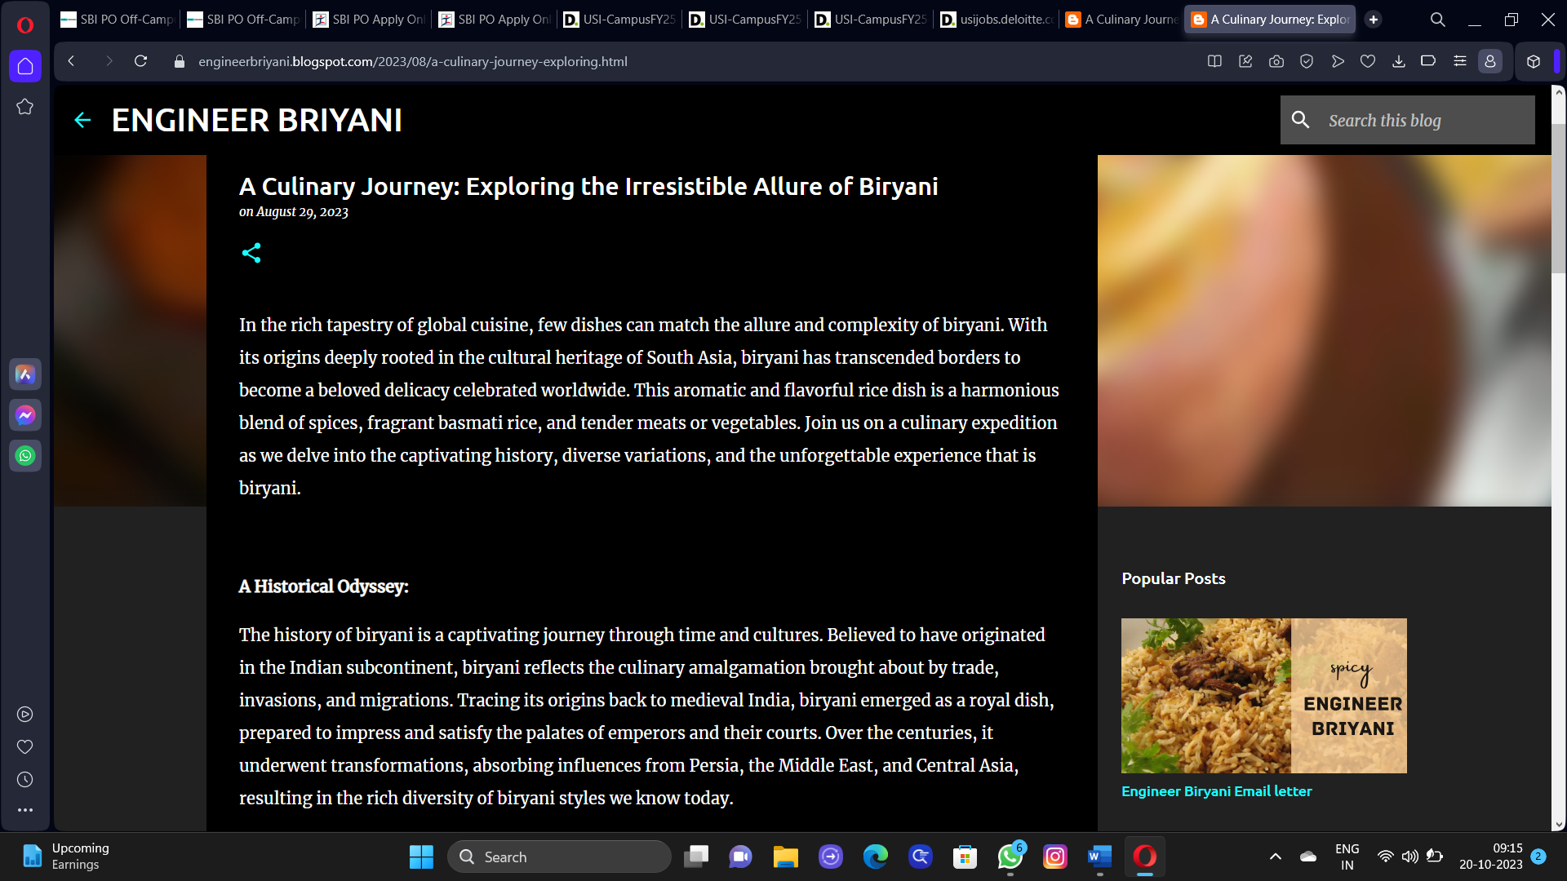

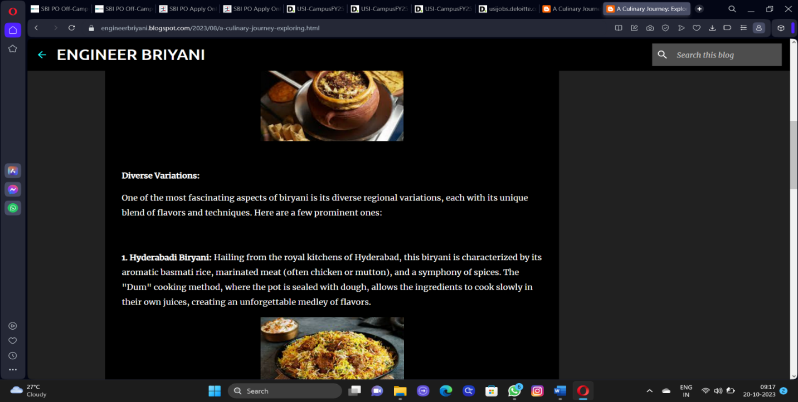

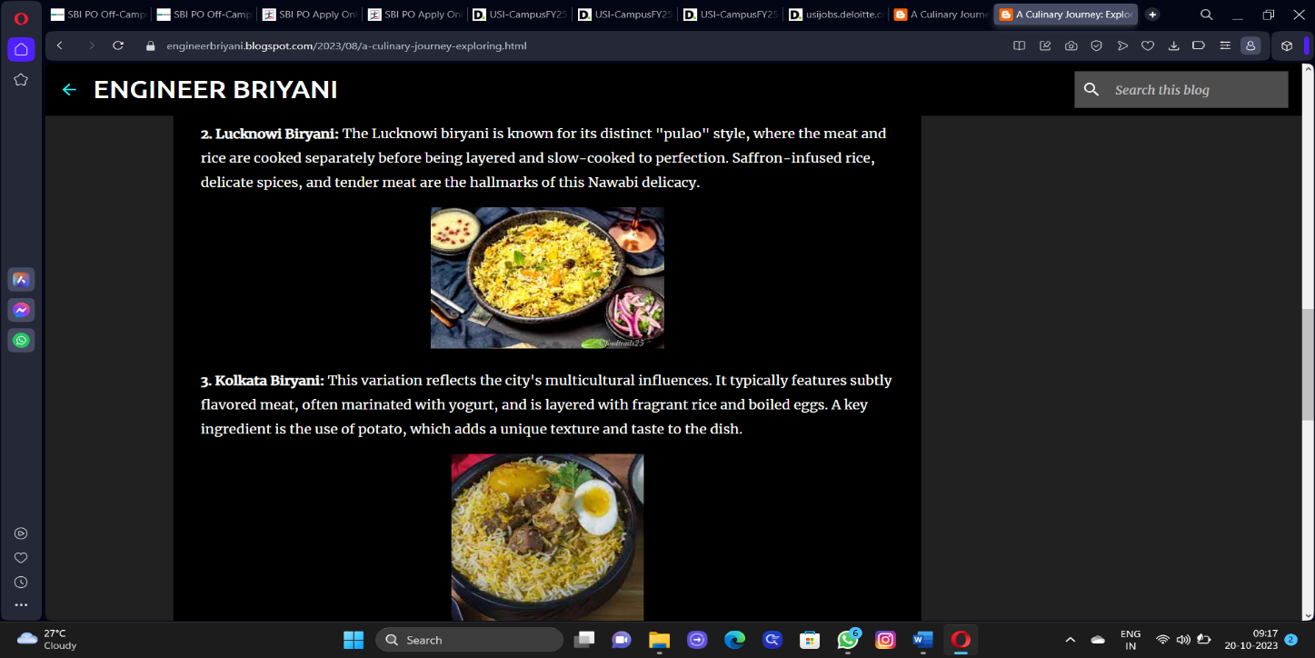

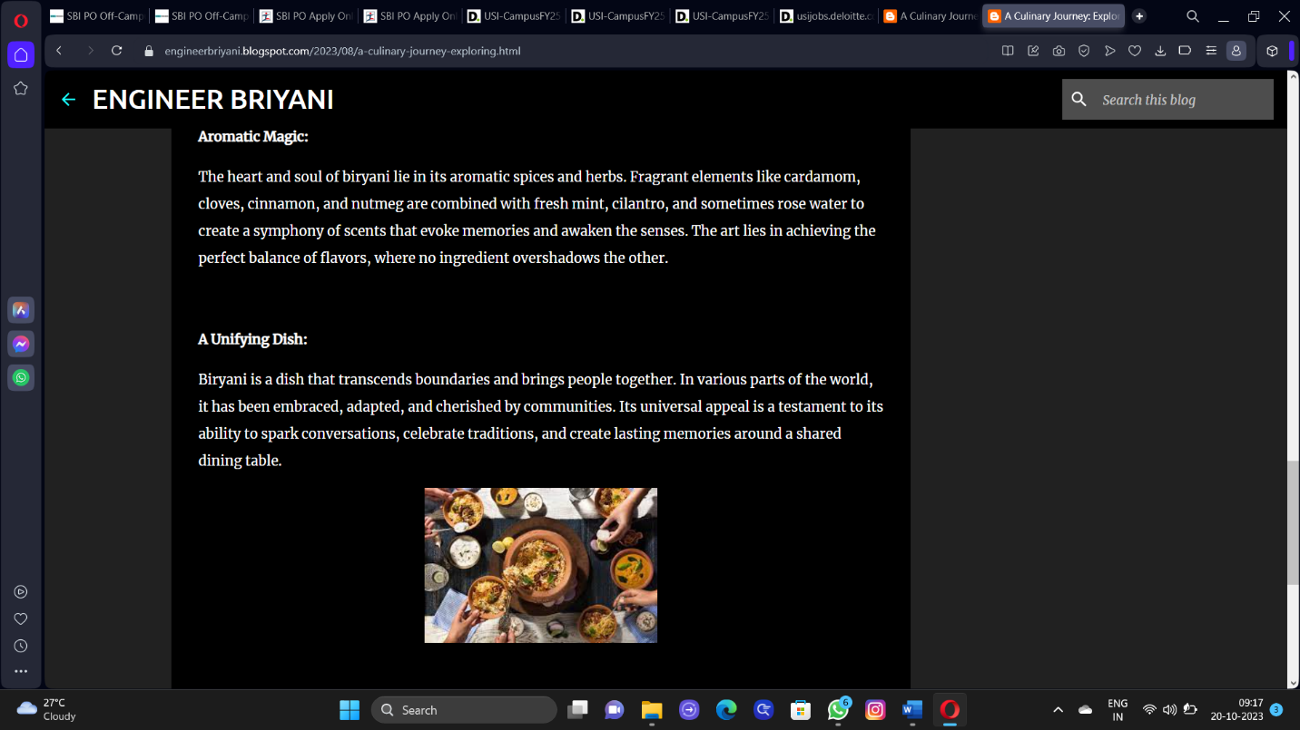

2.Create a New Facebook Business Page and post one social media poster for your brand.

Link: Facebook business page

<https://www.facebook.com/profile.php?id=61550773851816&mibextid=ZbWKwL>

Screen shot:

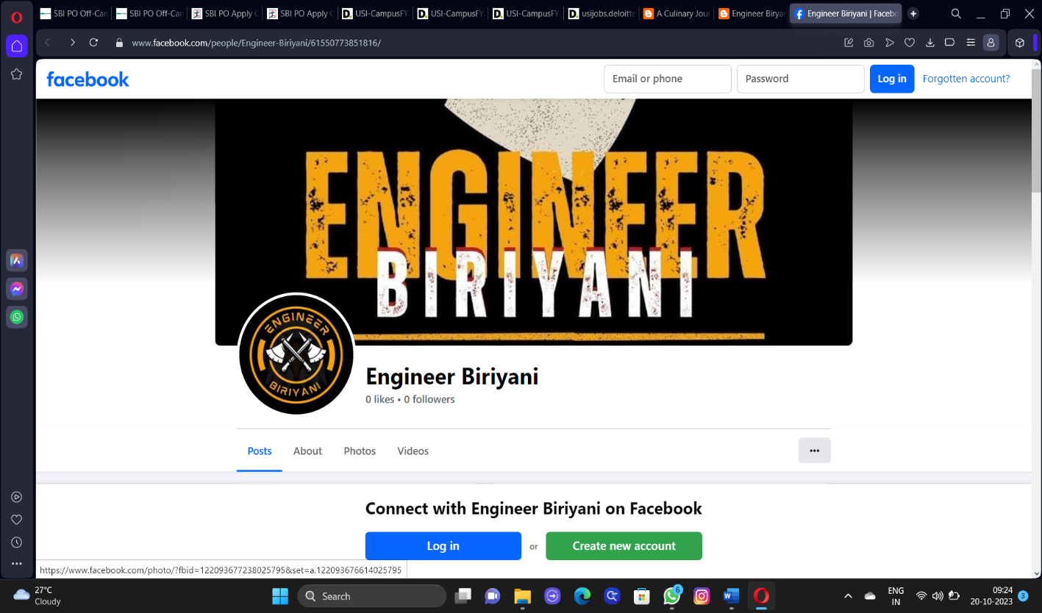

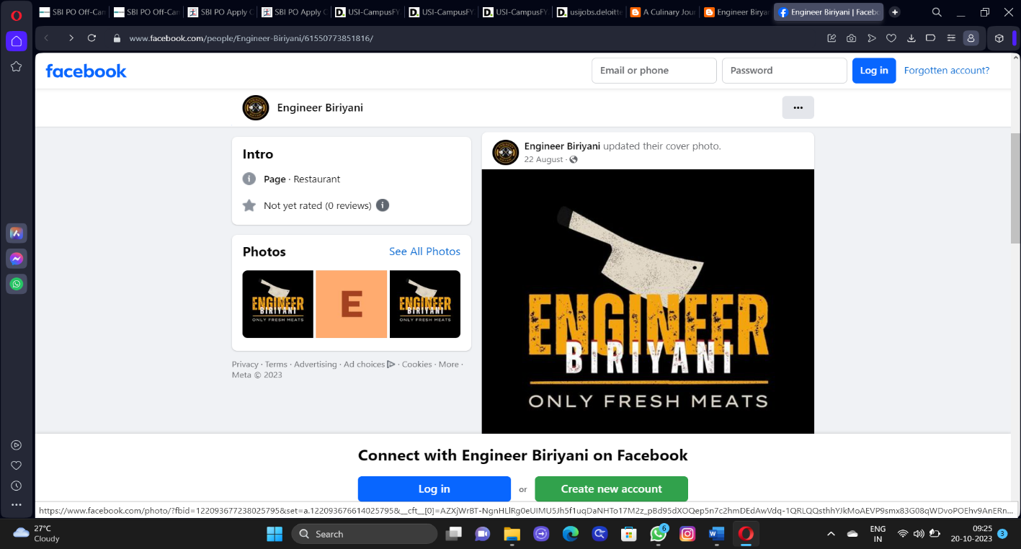

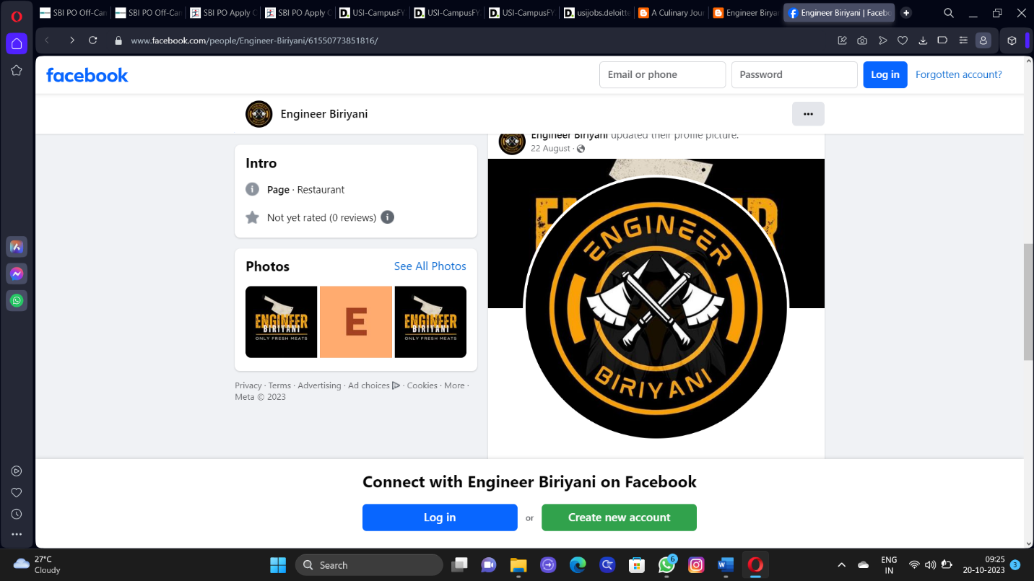

3.Create and design a social media advertisement poster using canva.

Link: Infographics Page Design using canva

<https://engineerbriyani.blogspot.com/2023/09/engineer-biryani-infographics.html>

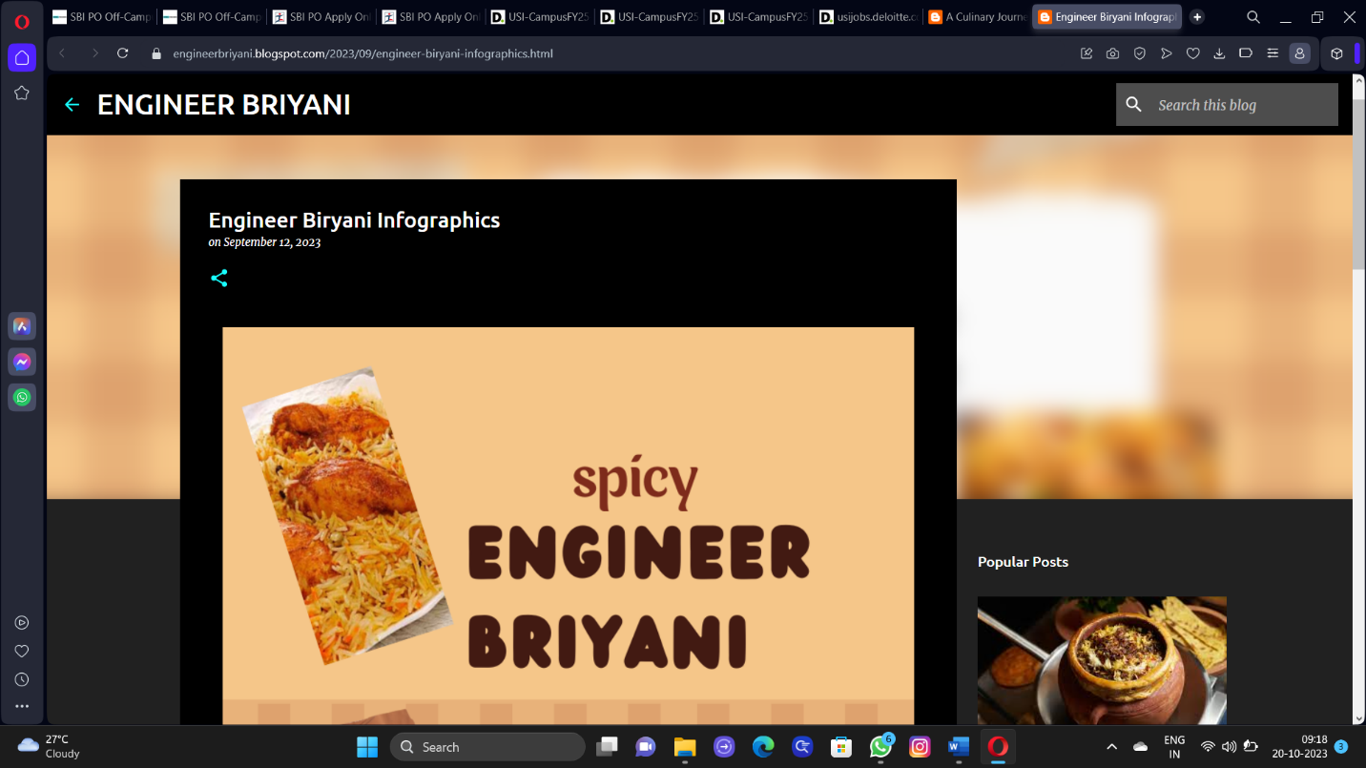

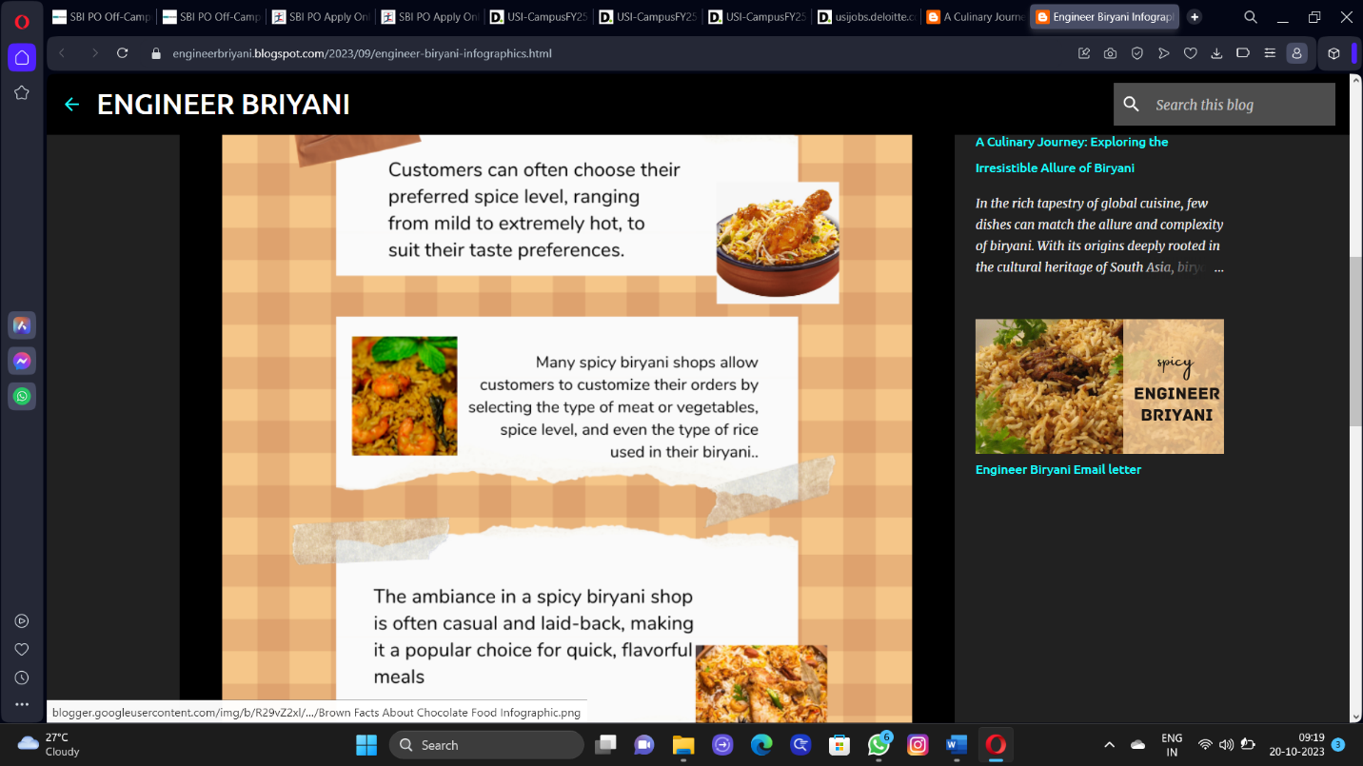

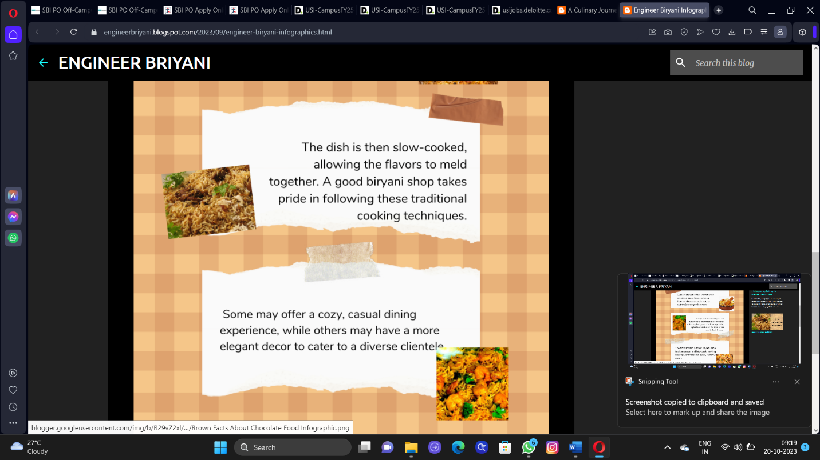

4.Create email newsletter design using MailChimp or canva tool.

Link: Email newsletter design using canva

<https://engineerbriyani.blogspot.com/2023/09/engineer-biryani-email-letter.html>

screen shot:

